CSyllabus

{Project Plan}

Version 1.0

**Revision History**

|  |  |  |  |
| --- | --- | --- | --- |
| **Date** | **Version** | **Description** | **Author** |
| 2017-10-23 | 0.01 | Initial Draft | Thomas Benetti |
| 2017-10-25 | 0.02 | Gant Diagram, Scope, Reference | Adrien Roques |
| 2017-11-03 | 1.0 | First Fully Completed Version | Adrien Roques |

# 

Contents

1. Introduction 5

1.1 Purpose of this document 5

1.2 Document organization 5

1.3 Intended Audience 5

1.4 Scope 5

2. Definitions and acronyms 5

2.1 Definitions 5

2.2 Acronyms and abbreviations 6

3. Background and Objectives 6

3.1 The customer 6

3.2 Project description 6

3.3 Project scope 6

3.4 Project vision 6

3.5 The supervisors 6

4. Impact 7

4.1 Who are the users 7

4.2 Impact of the system on the users 7

5. Project group 7

5.1 Members and contact info 7

5.2 Roles 8

6. Development process 9

7. Organization and communication 9

7.1 Meetings 9

7.1.1 Team meetings 9

7.1.2 Supervisors meetings 9

7.1.3 Customer meetings 9

7.2 Forms of contact 9

7.3 Worked time reports 10

7.4 Configuration management 10

8. Initial time plan 10

8.1 Planned sprints 10

8.2 Deadlines 10

8.3 Gantt chart 11

9. Quality assurance 14

10. Risks 15

# Introduction

## Purpose of this document

The purpose of this document is to provide an overview of the CSyllabus project to build a common understanding about this project and to describe the general organization of its development team. It defines the project vision, roles in the project team as well as describes the planned development process.

## Document organization

The document is organized as follows:

* Section 1, *Introduction,* describes contents of this guide, used documentation during developing process etc.
* Section 2, *Background and Objectives,* briefly introduces the customer and describes what’s the purpose of the project from the customer’s perspective.
* Section 3, *Impact,* describes who are the people interacting with the system and how will the system impact on their life.
* Section 4, *Project group,* defines the team members, their roles and the structure of the project team.
* Section 5, *Development process,* describes the SCRUM process from the point of view of the team.
* Section 6, *Organization and communication,* defines the meetings organization and the communication tools.
* Section 7, *Initial time plan,* defines a preliminary project schedule by organizing the project scrum sprints and indicates the initial deadlines, but also the Gantt chart.
* Section 8, *Quality assurance,* describes the QA process used for the project.
* Section 9, *Project risks,* defines the lists of potential risks involved in the project development as well as provides potential risk minimization actions that are going to be implemented by the team.

## Intended Audience

The intended audience is:

* The development team, to guide the initial project development and to ensure that the project vision is shared among the team members.
* The stakeholders, to inform them about the scope and planning of the project.
* Anyone who wants to know more about this project

## Scope

This document tries to address the general shape to the final product will have to deliver. It defines all the rules, standards and guidelines that the team has decided to choose. The overall organization of all members, including internal roles and development process are described.

## Definitions and acronyms

### Definitions

|  |  |
| --- | --- |
| **Keyword** | **Definitions** |
| SCRUM | An iterative and incremental agile software development framework for managing the development of a product. |
| Sprint | Basic unit of time of the project development cycle used in scrum. Usually this set of time is of 1 week to 1 month maximum. |
|  |  |

### Acronyms and abbreviations

|  |  |
| --- | --- |
| **Acronym or**  **abbreviation** | **Definitions** |
| **NTR** | Nothing to Report.  There is no information to a specific topic available or necessary. |
| **FER** | Faculty of Electrical Engineering and Computing, University of Zagreb |
| **POLIMI** | Politecnico di Milano, Italy |
| **SCORE** | Student Contest on Software Engineering |

# Background and Objectives

## The customer

The customer is Gruia-Catalin Roman, who is a professor of computer science at the University of New Mexico.

He proposed this project idea because he saw that searching for a syllabus is a big problem nowadays.

## Project description

The computer science faculty values free exchange of ideas, availability of open source software, open publications, exchange of pedagogical advances, etc. Yet, upon entering the website of a particular institution understanding the graduation requirements is often a real challenge and tracking the syllabus of a specific course can be a daunting undertaking. The goal of this project is to create a national repository of computer science course syllabi to assist student in making good educational choices, instructors in sharing best practices, and education researchers in understanding the evolution of our field.

## Project scope

Developing a site where students and faculty may upload syllabi in some standard format like .pdf is not much of a challenge. The real issues are how to encourage participation, how to curate the data, and how to present the data in a meaningful and useful fashion. Accomplishing this with minimal user interaction is the most difficult aspect of this undertaking. Automatically extracting information from the submitted documents will be an important first step in this direction.

## Project vision

Our application will be used to help the students choose courses. For that, the student will be able to choose his home university and if he wants, his wanted destination (via city, country or faculty name), plus the courses he wants to select. He will be able to select them by typing keywords that represent the courses. Then the application will analyze his input and match it with input data from syllabuses to find him suitable faculties and courses.

Our vision besides data gathering and analysis, is to add a community so that students can see feedback from previous students at the proposed universities and maybe contact them to have more informations. But also we would like to introduce to the student what he can see in the chosen city, the night life, the students’ occupations, etc…

## The supervisors

They are divided as following :

* Ivana Bosnic as local supervisor, checking process from FER.
* Raffaela Mirandola as remote supervisor, checking progress from POLIMI.

# Impact

## Who are the users

The users of the system are:

* the students that are searching for syllabi courses on universities
* the instructors that want to share best practice between them
* the researchers to understand the evolution of their field

## Impact of the system on the users

The system could help the users get data more easily, without looking out onto multiple faculties websites.

For students, it would help them look for syllabi course via a simple analyzer tool.

# Project group

## Members and contact info

The team is composed by 7 members that are distributed throughout the universities of POLIMI and FER involved in this project. The team is divided as following:

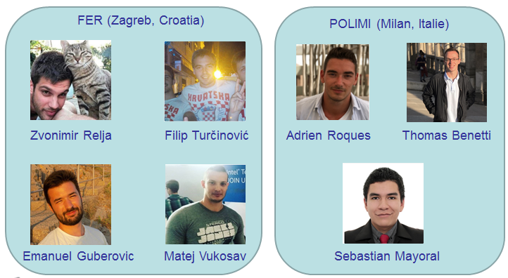

Contact info :

* Zvonimir Relja : [zvonimir.relja@fer.hr](mailto:zvonimir.relja@fer.hr)
* Filip Turcinovic : [filip.turcinovic@fer.hr](mailto:filip.turcinovic@fer.hr)
* Emanuel Guberovic : [emanuel.guberovic@fer.hr](mailto:emanuel.guberovic@fer.hr)
* Matej Vukosav : [matej.vukosav@fer.hr](mailto:matej.vukosav@fer.hr)
* Adrien Roques : [adrien.roques.31@outlook.fr](mailto:adrien.roques.31@outlook.fr)
* Thomas Benetti : [thomas.benetti@mail.polimi.it](mailto:thomas.benetti@mail.polimi.it)
* Sebastian Obando Mayoral : [obandomayoral@gmail.com](mailto:obandomayoral@gmail.com)

## Roles

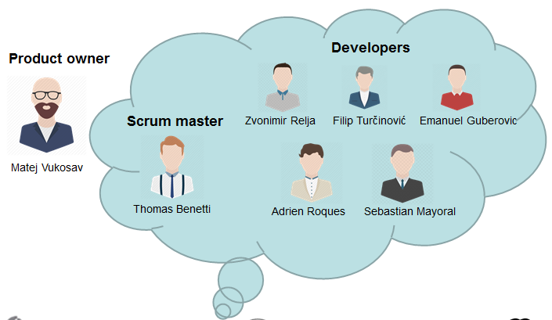

We used the SCRUM approach to define team roles, as following:

* The Product Owner, who is responsible for the product backlog and facilitate the communication between the customer and the development team
* The Scrum Master, who helps the team during all the SCRUM phases and facilitates the ceremonies
* The Development Team, who builds the increment product. The Product Owner and the Scrum Master works with the team.

We used Doodle to choose the project roles. The team has decided then that Matej Vukosav will be the Product Owner and that Thomas Benetti will be the Scrum Master. The Scrum Master will not change unless he doesn’t do his job well.

# Development process

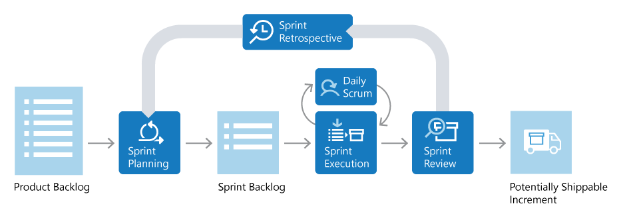

The development process will be done using the SCRUM approach. The team adjusted the SCRUM method in its own way to fit with everyone’s schedule and to suit better with the DSD course. Our SCRUM method is composed of:

* The product backlog that is going to be discussed with the customer.
* Each sprint will last 2 weeks. We chose this sprint time because of the team members’ availability to work on the project and the amount of work of each sprint.

# Organization and communication

## Meetings

### Team meetings

We currently have two types of team meetings:

* **Daily meetings**: with the SCRUM method, a meeting must be done every day of work, which includes the work done yesterday, the work that will be done today and what problems have been encountered by each team member. But as we are not working every day on this project, we are doing the daily meetings on Wednesday, Friday and Sunday.
* **Weekly meetings**: These meetings are done on Sunday and lasts 1 hour and a half. The planning of these meetings are :
  + If it is the end of a sprint: to do the sprint retrospective and plan the next sprint.
  + If it is the middle of a sprint (1 week): to check the current sprint’s progress.
  + If there is a presentation on the next Tuesday: to do the assignment of the 2 team members that will do the next oral presentation.

### Team and supervisors meetings

They are held on Fridays. They are used to control the progress of the project with the supervisors, but also to have their opinions.

### Customer meetings

The customer meetings are not held as team and supervisors meetings. They are held when its necessary for the project progress, and if the team has interrogations on some project caracteristics.

## Forms of contact

At first, all the meetings were done via Skype but we occured to have some troubles regarding Skype so we used Google Hangouts as a backup plan for internal meetings. The off-board communication is done via Slack, Google Drive or e-mail. We also use Kanban Flow for project management and Toggl for time tracking.

## Worked time reports

The worked time on any task is reported on Kanban Flow. Each team member use the task time log to enter the time spent on each task every day. When the task is done, it is compared to the estimated time to know how much and why it may be different.  
Kanban Flow also has a time tracking tool that is used by several team members. It allows them to launch a timer with pre-defined work time and breaks. In that way, they can define their schedule and after each time spent know why they overflowed the estimated work time.

But we had an issue with Kanban Flow regarding worked time : it cannot generate reports/analysis to use for sprint reports. So we used Toggl to enter our working hours and to be able to visualize metrics concerning our worked time.

## Configuration management

We use Git to manage multiple versions of our application, with everyone working on separate branches, it allows the work to be done without interferences and to keep stable versions of the application.

Also we use GitHub as the repository of Git applications versions. The repository is public as it is a SCORE project.

# Initial time plan

## Planned sprints

|  |  |  |  |
| --- | --- | --- | --- |
| **Sprint** | **Start date** | **End date** | **Description** |
| 0 | 2017-10-13 | 2017-10-27 | Research |
| 1 | 2017-10-27 | 2017-11-10 | Explorer and database |
| 2 | 2017-11-10 | 2017-11-24 | Comparator |
| 3 | 2017-11-24 | 2017-12-08 | Community |
| 4 | 2017-12-08 | 2017-12-22 | Validation |
| 5 | 2018-01-05 | 2018-01-19 | Final report |

## Deadlines

|  |  |  |
| --- | --- | --- |
| **Item** | **Type** | **Date** |
| Project vision and project plan | Presentation | 2017-10-17 |
| Requirements, design and revised project plan | Presentation | 2017-10-31 |
| Project plan document (v1) | Deliverable | 2017-11-03 |
| Requirements definition document (v1) | Deliverable | 2017-11-10 |
| Design description document (v1) | Deliverable | 2017-11-10 |
| Status report | Presentation | 2017-11-14 |
| Milestone – Alpha prototype | Presentation | 2017-11-28 |
| Milestone – Beta prototype | Presentation | 2017-12-12 |
| Acceptance test plan | Deliverable | 2017-12-22 |
| Final project | Presentation | 2018-01-09 |
| SCORE report | Deliverable | 2018-01-15 |
| Test report | Deliverable | 2018-01-19 |
| Final project report | Deliverable | 2018-01-19 |
| Final product | Deliverable | 2018-01-19 |

## Gantt chart

The activity plan is presented in the Gantt chart below. The activities and milestones are shown

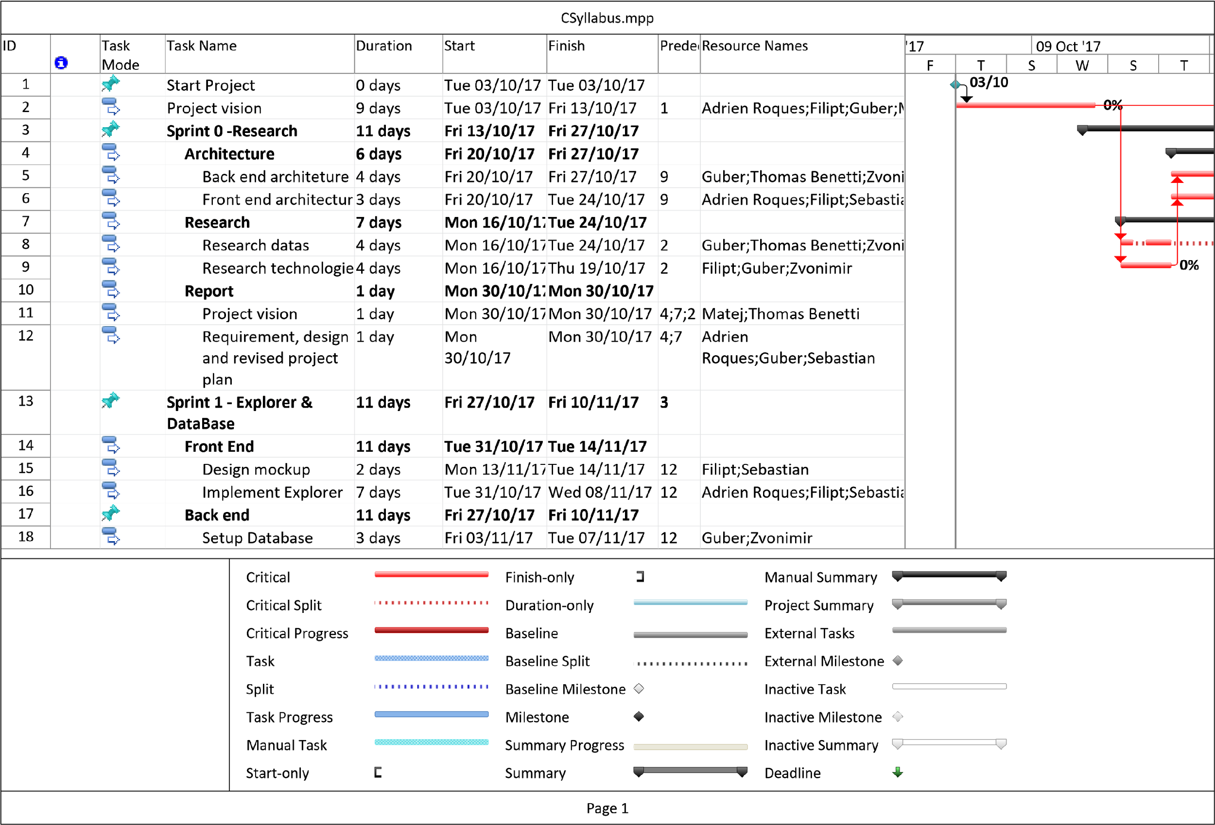

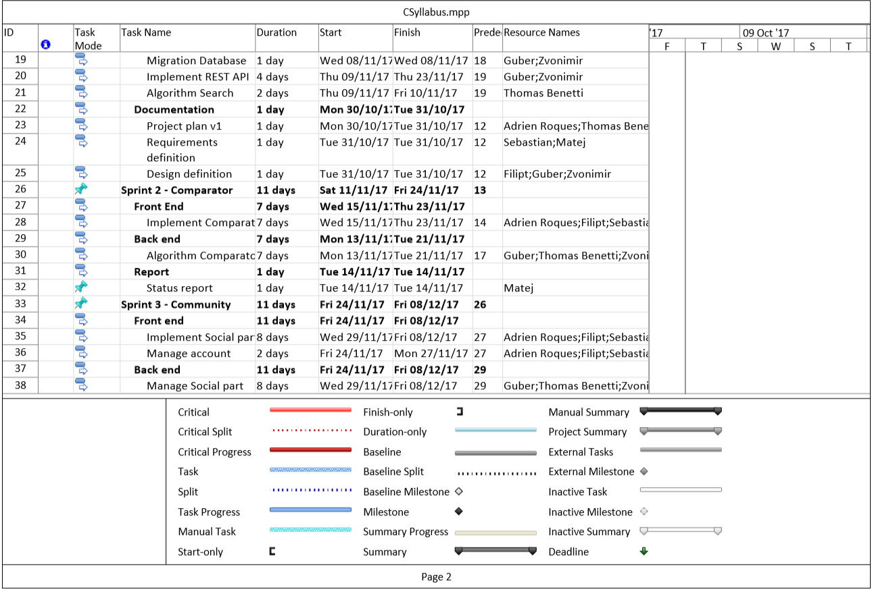

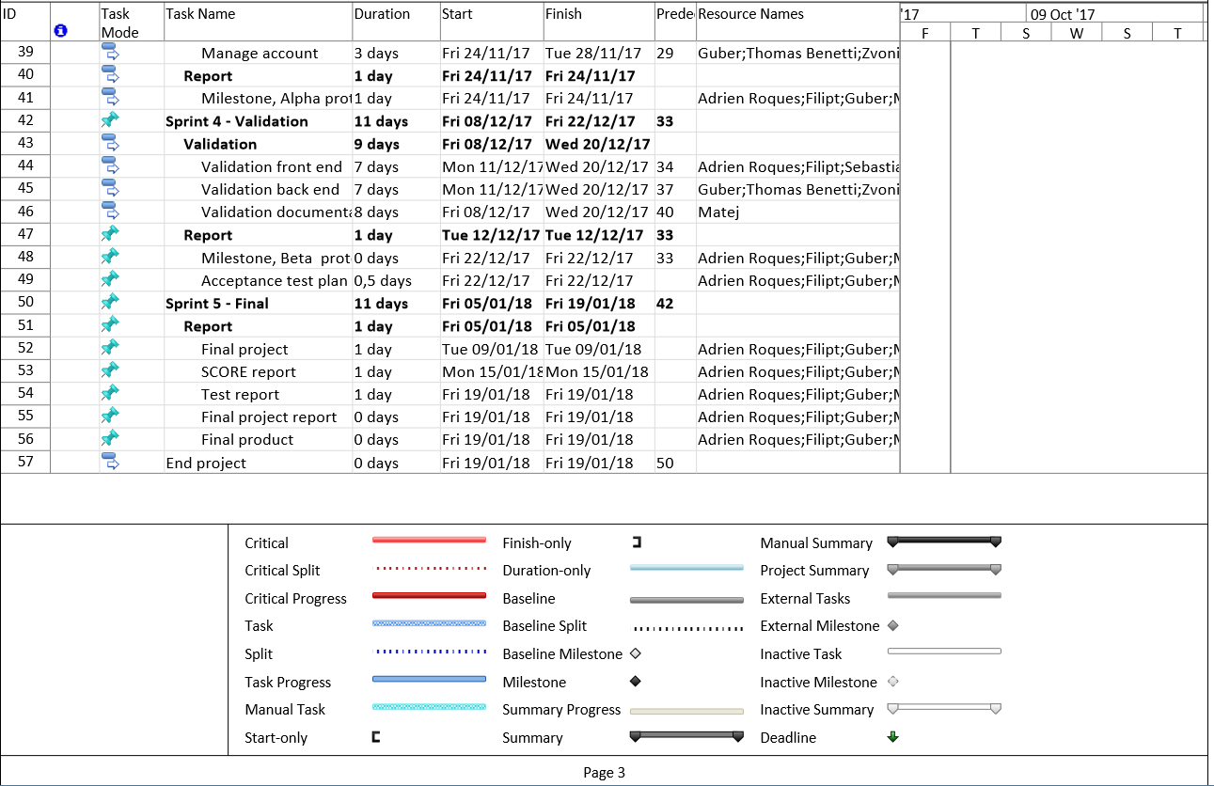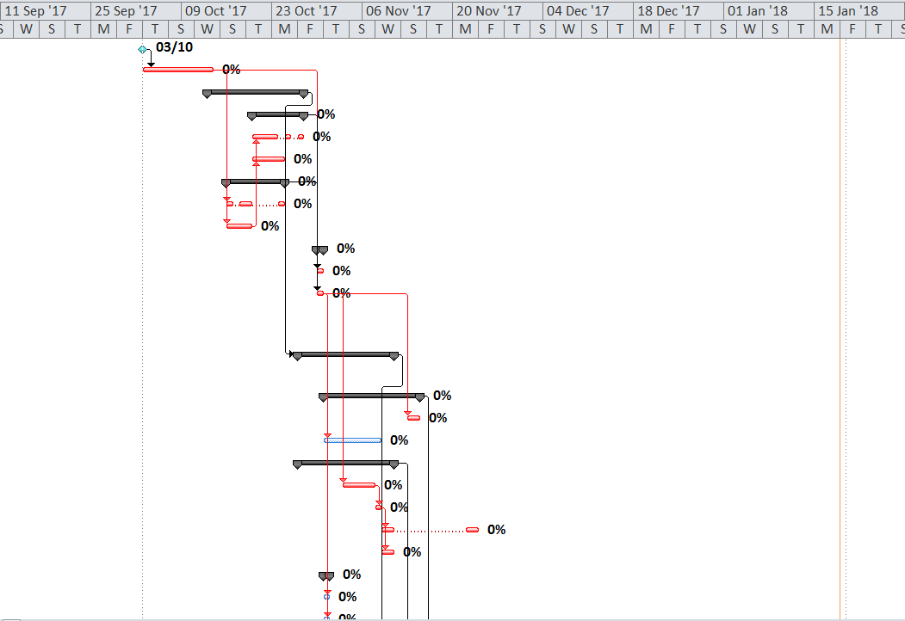

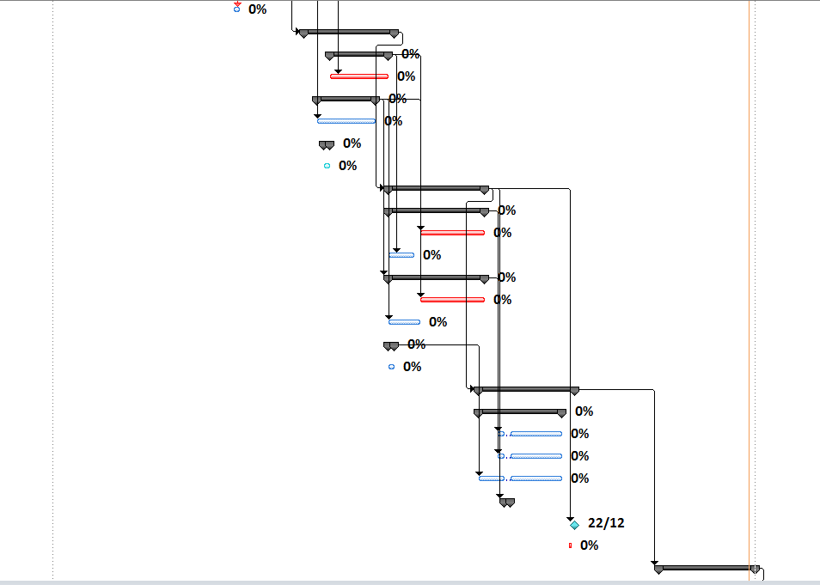

# Final time plan

## Planned sprints

|  |  |  |  |
| --- | --- | --- | --- |
| **Sprint** | **Start date** | **End date** | **Description** |
| 0 | 2017-10-13 | 2017-10-27 | Research |
| 1 | 2017-10-27 | 2017-11-10 | Explorer and database |
| 2 | 2017-11-10 | 2017-11-24 | Comparator |
| 3 | 2017-11-24 | 2017-12-08 | Community |
| 4 | 2017-12-08 | 2017-12-22 | Validation |
| 5 | 2017-12-22 | 2017-01-05 | Final report |

## Deadlines

|  |  |  |
| --- | --- | --- |
| **Item** | **Type** | **Date** |
| Project vision and project plan | Presentation | 2017-10-17 |
| Requirements, design and revised project plan | Presentation | 2017-10-31 |
| Project plan document (v1) | Deliverable | 2017-11-03 |
| Requirements definition document (v1) | Deliverable | 2017-11-10 |
| Design description document (v1) | Deliverable | 2017-11-10 |
| Status report | Presentation | 2017-11-14 |
| Milestone – Alpha prototype | Presentation | 2017-11-28 |
| Milestone – Beta prototype | Presentation | 2017-12-12 |
| Acceptance test plan | Deliverable | 2017-12-22 |
| Final project | Presentation | 2018-01-09 |
| SCORE report | Deliverable | 2018-01-15 |
| Test report | Deliverable | 2018-01-19 |
| Final project report | Deliverable | 2018-01-19 |
| Final product | Deliverable | 2018-01-19 |

## Comparison of Gantt chart with initial plan

|  |  |  |  |  |  |  |  |  |  |  |  |  |  |
| --- | --- | --- | --- | --- | --- | --- | --- | --- | --- | --- | --- | --- | --- |
| Activity | S0 | S1 | S2 | S3 | S4 | S5 |  | S0 | S1 | S2 | S3 | S4 | S5 |
| Project preparations |  |  |  |  |  |  |  |  |  |  |  |  |  |
| Requirements analysis |  |  |  |  |  |  |  |  |  |  |  |  |  |
| Back-end architecture |  |  |  |  |  |  |  |  |  |  |  |  |  |
| Front-end architecture |  |  |  |  |  |  |  |  |  |  |  |  |  |
| Data search |  |  |  |  |  |  |  |  |  |  |  |  |  |
| Technologies search |  |  |  |  |  |  |  |  |  |  |  |  |  |
| Mockup design |  |  |  |  |  |  |  |  |  |  |  |  |  |
| Explorer |  |  |  |  |  |  |  |  |  |  |  |  |  |
| Database setup |  |  |  |  |  |  |  |  |  |  |  |  |  |
| Rest API |  |  |  |  |  |  |  |  |  |  |  |  |  |
| Comparator |  |  |  |  |  |  |  |  |  |  |  |  |  |
| Social part |  |  |  |  |  |  |  |  |  |  |  |  |  |
| Accounts |  |  |  |  |  |  |  |  |  |  |  |  |  |
| Testing |  |  |  |  |  |  |  |  |  |  |  |  |  |
| Documentation |  |  |  |  |  |  |  |  |  |  |  |  |  |
| Conferences |  |  |  |  |  |  |  |  |  |  |  |  |  |

***The Gantt diagram created before starting developing on left and actual one on right.***

As shown on this figure, we had multiple tasks to work on and so we divide them into the sprints taking into consideration their order, estimated time and relevance using the Scrum approach.

During the project, at the end of each sprint, we defined which tasks were not done and regarding their importance, we reported them into the next sprint or deleted them when we thought we won’t have enough time to successfully complete them (« Accounts » task for example)

Except this task, we succeeded in following the plan with some small modification on the planning flow due to overtime spent in some activities. (for example, we needed to improve comparator algorithm).

# Quality assurance

To ensure that the quality of each component is maximal, we are using cross-validation. It means that each feature that is developed and tested by a team member is then tested again by another team member. That allows the verification of each feature goals and what the feature was supposed to do.

# Risks

|  |  |  |
| --- | --- | --- |
| **N°** | **Description** | **Actions** |
| 1 | **Project vision understanding :**  It is a key element of the project because as the development of the project is distributed throughout FER and POLIMI, we must be sure that all the ideas have been understood by each team member whatever is his location. | Communicate the most possible between all the team members and ask them to explain what is clear for them about the project vision. |
| 2 | **High Workload:**  Some tasks in the process may require more time to complete than expected. | To avoid problems with exceeding the deadlines, We will assign tasks to team members regarding the tasks’ priority. |
| 3 | **Indisponibility :**  Departure or indisponibility of a team member. Unable to reach him for project tasks. | Alert supervisors of the problem and if it’s not solved, re-assign his tasks to the other team members, with re-prioritizing the most important tasks due to deadlines and lack of time. |
| 4 | **Data issues :**  If the database is not populated enough, that there’s not enough courses for students to be able to use the app. | We must re-prioritize the tasks with as high priority, the data seek/search in order to make our website usable. |
| 5 | **Community issues :**  If there’s no registration for the app community and that no one wants to use our website. | Contact our friends who are able to use it so that it can help start the app to be known and to be recognized as a very helpful tool. |